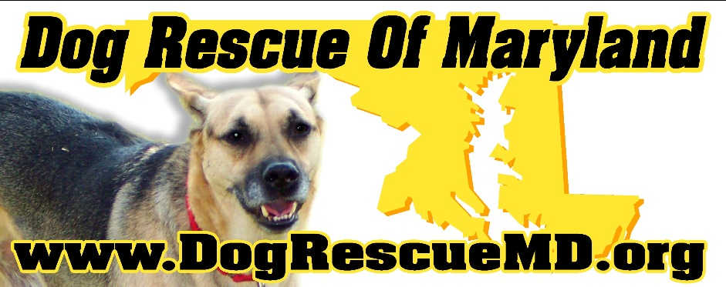 | P.O. Box 515  Pasadena, Maryland 21123  410-320-5010  dogrescuemd@live.com

VOLUNTEER APPLICATION

Thank you for your interest in our organization. Dog Rescue of Maryland, Inc. (DRM) is always looking for dedicated volunteers. Please complete the information below if you are interested in volunteering. Do not use this form to apply to be a foster "parent" to our dogs, instead, please use the Foster Application. This application is for all other volunteer activity.

DRM and its volunteers use an Online Discussion Forum for notification of events, needs and keeping everyone up to date. In order to become a volunteer it will be necessary to be included on this Forum. Please be sure to include your e-mail address. You will also be expected to take part in a rescue related event as soon as possible (store adoption day, meeting, fundraiser, etc). This will allow you to get the feel of what is needed, and us to know you are serious about volunteering.

Are you over the age of 18? Yes No, If you checked “NO”, please stop here.

DATE:
NAME:
ADDRESS:
CITY: |  |  |  |  |  |  | STATE: |  |  | ZIP CODE:
COUNTY:
DAYTIME PHONE:
EVENING PHONE:
MOBILE PHONE:
BEST TIME TO CALL:
EMAIL ADDRESS:
 | DRM uses an online discussion Forum as means of communication. Please provide an email address so that you can be kept up to date on rescue news.

REFERENCES: (NO RELATIVES, PLEASE)
1. | NAME: |  |  |  | PHONE NUMBER:
 | ADDRESS:
2. | NAME: |  |  |  | PHONE NUMBER:
 | ADDRESS:
3. | NAME: |  |  |  | PHONE NUMBER:
 | ADDRESS:

Have you ever done rescue work before? Yes No
If yes, please provide organization name, address and contact phone number. Also, please describe your duties:
If no, please explain why you wish to start.

Do you currently have any pets? Yes No
Please list pets below:
 | Type of Animal | Breed | Age | Pet’s Name
1
2
3
4
5

Please check which of the following areas you would be able to donate your time:
 | ADMINISTRATIVE HELP |  | NEWSLETTER
 | EVENTS |  | PHONE CALLS (reference/follow-up)
 | EVENTS (PETSMART/PETCO TABLES) |  | TRAINING
 | FUNDRAISING (planning/development) |  | TRANSPORTING
 | FUNDRAISING (selling/event help) |  | WEBSITE
 | HOME VISITS

What days of the week will you be available to volunteer?
 | DAY | EVENING
WEEKDAYS
SATURDAY
SUNDAY

How many hours per week will you be available to volunteer?

If you have any talents not covered above that you would be willing to contribute, please describe:

Dog Rescue of Maryland, Inc. (DRM) appreciates your interest in becoming a volunteer for our organization. You must understand that most of the dogs that come into our rescue come from shelters and humane societies or as strays, so their complete history is not known. It is possible that the dogs we take into our rescue have been abandoned, neglected, mistreated, or even abused. Although we evaluate dogs prior to accepting them into the rescue, we cannot guarantee the temperament of any of the dog (since most of their histories are unknown). Working with the rescued dogs comes with risks. By signing and submitting this application you are acknowledging that you understand and accept these risks.

By signing this application your certify that you have accurately completed this application and all information stated is correct. I have read the above warning and understand the risks involved in working with these dogs. I understand that DRM cannot be held responsible for the actions, behavior and/or medical condition of all of the dogs in its rescue. I agree to assume the risks implicit with working with dogs who may have been abandoned, beaten, or otherwise mistreated or abused or who may suffer from an illness, condition or disease. By signing below I am agreeing that I have never been convicted of animal abuse, neglect, or cruelty in the past and should this change you agree to either inform DRM immediately or remove yourself from the rescue. DRM takes its protection of animals seriously and insists that its volunteers do so as well. DRM reserves the right to refuse applicants based on what is in the best interests of the rescue and its continued successful operation. Should an applicant or a volunteer at any time be deemed a liability to the rescue, the dogs, or the rescues’ name, DRM retains the right to excuse individuals from the rescue volunteer base.

SIGNATURE OF APPLICANT |  | DATE

Thank you for offering to donate your time and energy to help find forever homes for unwanted/abused dogs. Please sign and date this form and mail it to Dog Rescue of Maryland. Inc., P.O. Box 515, Pasadena, Md. 21123 or attach the completed application to an email and send it to dogrescuemd@live.com. If sending application by email, the email and attached application will serve as your signature.

